MINI PROJECT REPORT

at

AXIS INSTITUTE OF TECHNOLOGY AND MANAGEMENT

### SUBMITTED IN PARTIAL FULFILLMENT OF THE REQUIREMENT FOR THE AWARD OF THE DEGREE OF

**BACHELOR OF TECHNOLOGY**

(Information Technology)

 

**SUBMITTED BY:**

### VAIBHAV SHARMA (1907190130036)

### VIRENDRA KUMAR NISHAD (1907190130040)

### DEPARTMENT OF COMPUTER SCIENCE AND ENGINEERING

AXIS INSTITUTE OF TECHNOLOGY AND MANAGEMENT

# CANDIDATE'S DECLARATION

I “Vaibhav Sharma and Virendra Kumar Nishad” hereby declare that I have undertaken Mini Project at “AXIS COLLEGES” during a period from November to December to partial fulfillment of requirements for the award of degree of B.Tech (Information Technology). The work which is being presented in the Mini Project report submitted to Department of Computer Science and Engineering at AXIS INSTITUTE OF TECHNOLOGY AND MANGEMENT, KANPUR is an authentic record of project work.

Signature of the Student

The Software training Viva–Voce Examination __________________ of has been held on ____________ and accepted.

**ABSTRACT**

One of the major factors contributing to traffic accidents is drowsiness and weariness. Taking steps to get enough sleep before driving, drinking coffee or energy drinks, or as sleepiness begins to show, take a nap. The widely used drowsiness detection technique makes use of sophisticated techniques like EEG and ECG. Although this method's measurement accuracy is quite good, it requires touch measurement and has various limitations when it comes to driver fatigue and drowsiness monitors.

As a result, using it while driving in real time is uncomfortable. The eye closure rate and yawning rate are two indicators of driver tiredness that this article suggests measuring. A participant will operate the driving simulation system while a webcam is set up in front of it for the video. The camera will be used to record the video, which will show the change from awake to tired and then to drowsy.

The system's task is to identify the face region in a video image that has been taken. The goal of employing the face region is to enable it to focus on detecting mouth and eyes within the face area. The eyes and mouth are located after the face has been located by constructing the eye for left and right eye detection as well as mouth detection. The facial image is used to establish the parameters for the eyes and mouth detection. The footage was converted into frames per second images. The eyes and lips can then be found from there. Once the eyes have been identified, the state of the eyes is determined by analysing intensity variations in the eye region. If the driver's eyes are closed for fifteen consecutive frames, it is confirmed that they are closed due to fatigue.

**ACKNOWLEDGEMENT**

I would like to express my profound and sincere gratitude to my faculty guide **Dr. Shalini Gupta** for guidance and support, who helped me to finish this project.

Her suggestion and instructions have served as the proper guide towards completion of this project.

I would also like to extend my gratitude to **H.O.D Ma’am Dr. Shubha Jain** for providing me with all the facility that was Required.

**Vaibhav Sharma (1907190130036)**

**Virendra Kumar Nishad (1907190130040)**

**CONTENT**

**Topic Page No.**

**Candidate’s Declaration 2**

**Abstract 3**

**Acknowledgement 4**

1. **Chapter 1: Introduction to Organization 6**
   1. About the Organization
   2. Vision of the Organization
   3. Mission of the Organization
   4. Core Values of the Organization
2. **Chapter 2: About This Project 7**
   1. Introduction
   2. Literature
   3. Objective
3. **Chapter 3: Module Description 8-9**
   1. Data Collection
   2. Algorithm
   3. Transfer Learning
4. **Chapter 4: Finishing the Project 10-11**
   1. Conclusion
   2. Future Scope

**Appendix 12**

**References 13**

**CHAPTER 1**

**INTRODUCTION TO ORGANIZATION**

* 1. **About the organization**

The Axis Colleges (AITM) is a benefit association enrolled in India (Kanpur). We envision a universe of little personalities engaged and associated, to construct a future. We plan to motivate understudies, help them set up, and let them meet up to assemble the up-and-coming age of mankind. We assist understudies with getting and help one another, gain from one another, and do well together.

* 1. **Vision of the organization**

Vision of this organization is “Tomorrow First”.

* 1. **Mission Of the organization**

Statement- To inspire students, help them innovate and let them integrate to build the next generation humankind. Inspire- To inspire, motivate and encourage students to learn, create and help build a better society. Innovate- To teach new ways of thinking, to innovate and solve the problems on their own. Integrate- To let the students integrate, and help each other, learn from each other and do well together.

* 1. **Core Values of the organization**
* Commitment
* Integrity
* Training
* Excellence
* Quality
* Professionalism
* Resilience

**CHAPTER 2**

**ABOUT THIS PROJECT**

* 1. **Introduction**

One of the main causes of most traffic accidents is driver intoxication. The dangers of being drowsy on the road can sometimes result in fatalities and significant financial losses as well as serious injuries. Drowsiness while operating a vehicle is associated with feeling lethargic, losing focus, and having fatigued eyes. India has a high accident rate because of distracted driving on the part of the drivers. Due to sleepiness, the driver's performance gradually declines. We created a system that can recognise the driver's drowsiness and alert him right away to prevent this anomaly. Using a camera, this system records images as a video stream, locates the eyes, and recognises faces. The algorithm is then used to analyse the eyes for drowsiness detection. The driver receives a drowsiness alarm via an alarm system based on the outcome.

* 1. **Literature**

There are many previous researches regarding driver drowsiness detection system that can be used as a reference to develop a real-time system on detecting drowsiness for drivers. There is also several method which use different approaches to detect the drowsiness signs. Image processing in computer science refers to the manipulation of images using computer algorithms. Image processing, a branch of digital signal processing, has many benefits over analogue image processing. It allows the application of a much wider variety of algorithms to the input data and can prevent issues like the distribution of noise and signal distortion during processing. Digital image processing can be modelled as a multidimensional system since images are defined in two dimensions.

* 1. **Objective**

The cause of a lot of traffic accidents is drowsy driving. Drowsiness can be identified by continuously streaming video of the driver using a camera or mobile device. The overall goal is to develop a model that can tell whether someone is feeling sleepy. The model takes an image every second, looks for blinking eyes, and uses an algorithm to determine when an eye closes. When the eye is closed for a long time, the driver will be alerted by a sound.

**CHAPTER 3**

**MODULE DESCRIPTION**

* 1. **Data collection**

The most important part of this project is the data. The information must be reliable and true. Data must be gathered from the appropriate sources, and every record must contain all the fields required for the analysis. It can be obtained from online sources or manually collected for greater accuracy. We are using a dataset which is just one part of The MRL Eye Dataset. It is prepared for classification tasks and this dataset contains infrared images in low and high resolution, all captured in various lighting conditions and by different devices. To simplify the comparison of algorithms, the images are divided into several categories, which also makes them suitable for training and testing classifiers.

* 1. **Algorithm**

Haar Cascade is an Object Detection Algorithm that is used to find faces in still photos or moving videos.

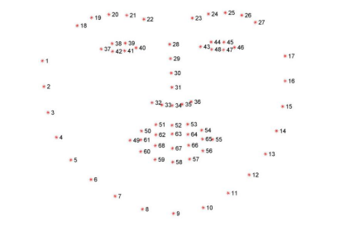

Fig 1: Visualizing the 68 facial coordinates.

The edge or line detection features Viola and Jones suggested in their 2001 study "Rapid Object Detection using a Boosted Cascade of Simple Features" are used by the algorithm. To train, the algorithm is given many positive images with faces and many negative images without any faces.

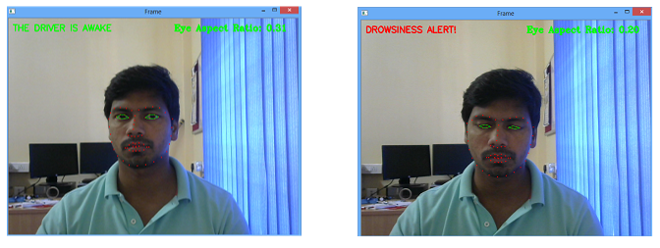

Fig 2: Using Haar Cascade to extract Eye from video.

* 1. **Transfer learning**

The process of applying a model that has already been learned to address a fresh problem is known as transfer learning. It is especially well-liked in the field of deep learning because deep neural networks can currently be trained using little to no data. Because most real-world scenarios don't require training complex models using millions of labelled data points, this is especially helpful in the field of data science.

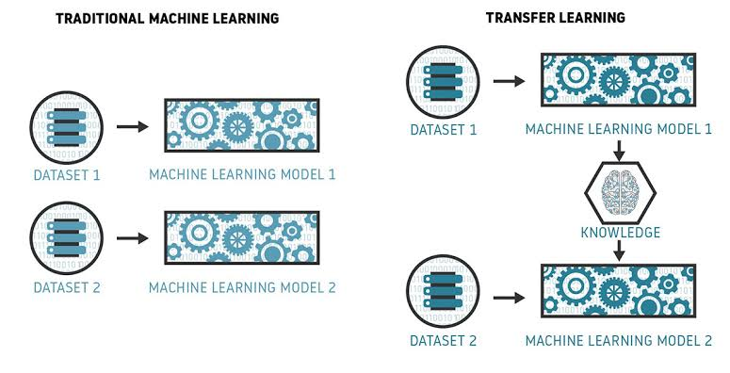

Fig 3: Flowchart of Transfer Learning.

Inception v3 is an image recognition model that has been shown to attain greater than 78.1% accuracy on the ImageNet dataset.The third version of the inception architecture, which was initially created for the GoogleNet model, is known as inceptionV3.  Rethinking the Inception Architecture for Computer Vision, a 2015 paper that describes the model, was written by Google researchers. The model expects colour images to have the square shape 299×299.

**CHAPTER 3**

**FINISHING THE PROJECT**

* 1. **Conclusion**

An automated system for detecting driver drowsiness was developed in the current study. Drowsiness is determined by reading the continuous video stream from the system. Using the Haar cascade algorithm, it is discovered. Haar features are used by the haar cascade algorithm to find faces and eyes. Predefined Haar features are employed to detect a variety of things. The haar features are applied to the image, and the perclos algorithm is used to determine blink frequency. If the value stays at 1, it recognises that the user is sleepy and alerts the driver by sounding an alarm. The driver is distracted and an alarm is set off if the value stays the same for extended periods of time.

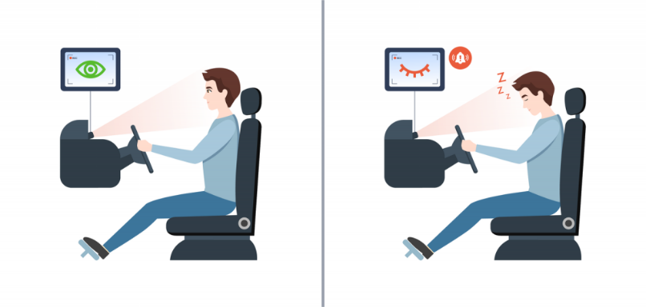

Fig 4: Visualizing the outcome.

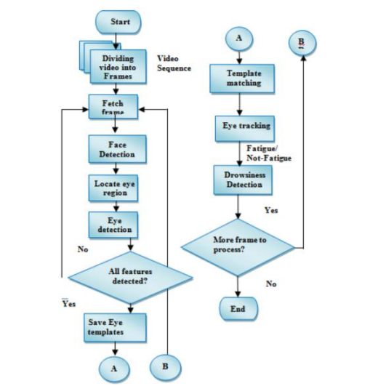

Fig 5: Flowchart Process of Drowsiness Detection System.

* 1. **Future Scope**

The model can be improved by using additional parameters such as blink rate, yawning, car condition, etc. The accuracy can be greatly increased if all these parameters are used. To stop accidents caused by sudden heart attacks in drivers, we can add a sensor to track heart rate. The same model and methods can be applied to a variety of other applications, such as allowing Netflix and other streaming services to recognise when a user is falling asleep off and stop the video accordingly. It can also be utilised in software that keeps users from falling asleep.

**APPENDIX**

**Python**

Python is a general-purpose, interpreted programming language. Its language constructs and object-oriented methodology are designed to aid programmers in creating clean, comprehensible code for both little and big projects. Python has garbage collection and dynamic typing. Programming paradigms like procedural, object-oriented, and functional programming are all supported.

**TensorFlow**

TensorFlow is a free and open-source software library for machine learning and artificial intelligence. It can be used across a range of tasks but has a particular focus on training and inference of deep neural networks.

**Keras**

It allows use of distributed training of deep-learning models on clusters of Graphics processing units (GPU) and tensor processing units (TPU).

**OpenCV**

OpenCV is the huge open-source library for the computer vision, machine learning, and image processing. Using it, one can analyse pictures and videos to find faces, objects, and even human handwriting.

**REFERENCES**

1. Association for Safe International Road Travel (ASIRT), Road CrashStatistics. http://asirt.org/initiatives/informingroadusers/road-safety-facts/road-cras h-statistics, 2016
2. Picot, S. Charbonnier, and A. Caplier, "On-line automatic detection of driver drowsiness using a single electroencephalographic channel," in Engineering in Medicine and Biology Society, 2008. EMBS 2008. 30th Annual International Conference of the IEEE, 2008, pp. 3864-3867.
3. G. Borghini, L. Astolfi, G. Vecchiato, D. Mattia, and F. Babiloni, "Measuring neurophysiological signals in aircraft pilots and car drivers for the assessment of mental workload, fatigue and drowsiness," Neuroscience & Biobehavioral Reviews, 2012.
4. Eye Detection Using Morphological and Color Image Procesing TanmayRajpathaka, Ratnesh Kumar and Eric Schwartzb
5. [https://docs.opencv.org/trunk/d7/d8b/tutorial_py_face_de tection.html](https://docs.opencv.org/trunk/d7/d8b/tutorial_py_face_de%20tection.html)
6. Facial Features Monitoring for Real Time Drowsiness Detection byManu B.N, 2016 12th International Conference on Innovations in InformationTechnology (IIT) [Pg. 78-81] https://ieeexplore.ieee.org/document/7880030
7. <https://github.com/opencv/opencv/tree/master/data/haarcascades>
8. http://mrl.cs.vsb.cz/eyedataset
9. Real Time Drowsiness Detection using Eye Blink Monitoring by Amna RahmanDepartment of Software Engineering Fatima Jinnah Women University 2015 NationalSoftware Engineering Conference (NSEC 2015) https://ieeexplore.ieee.org/document/7396336